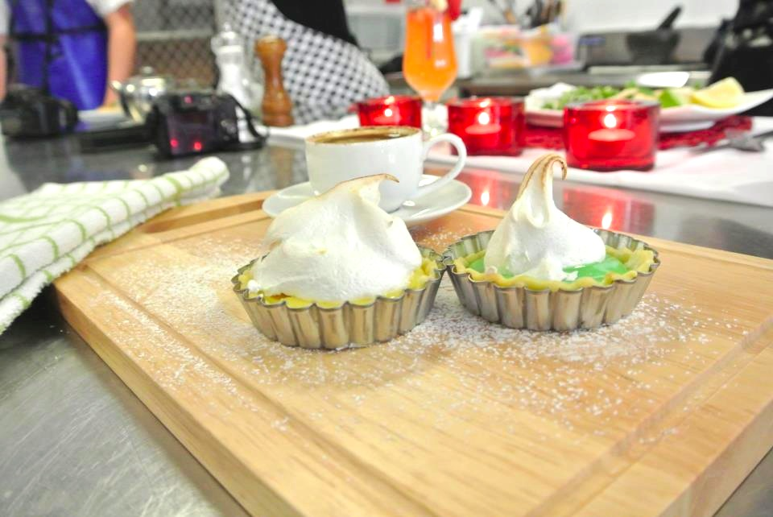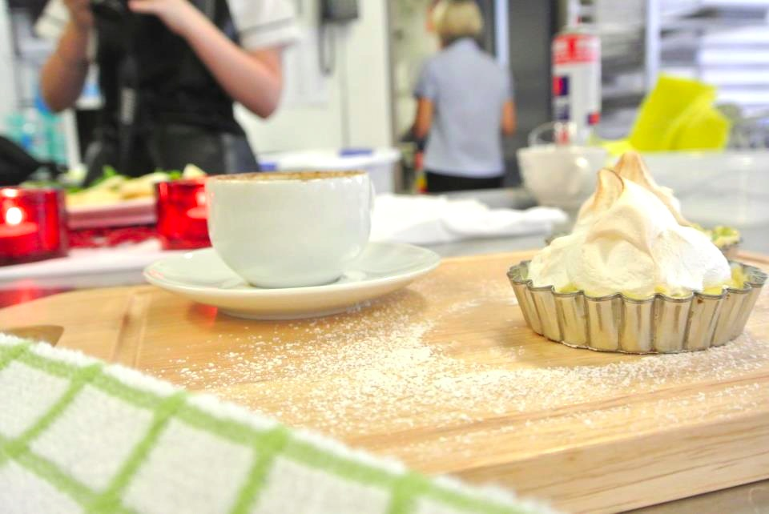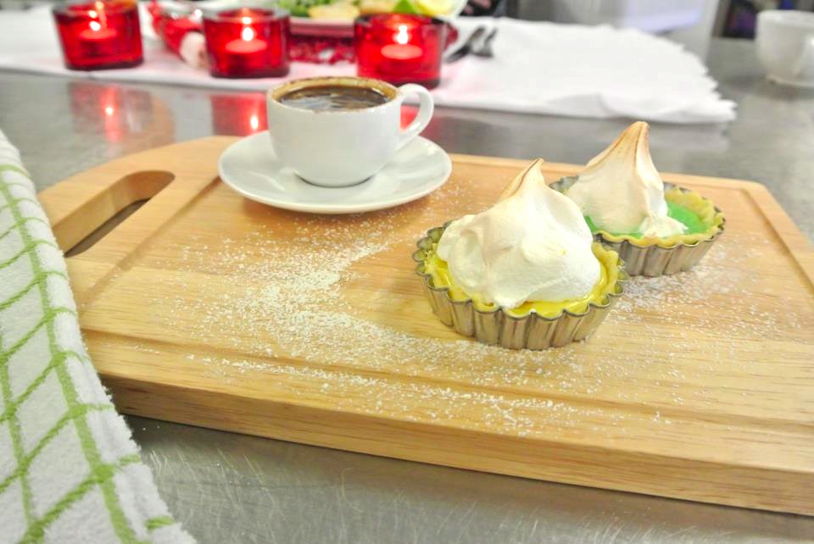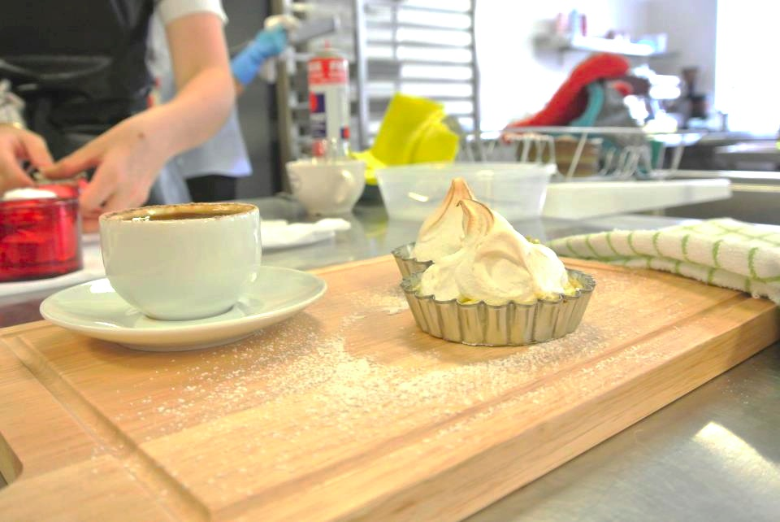

**Mini Lemon and Lime Meringue Pies**

**Mel Zeman**

**Preparation: 5 Mins**

**Cooking: 25 Mins**

**Serving / Presentation: 5-10 Mins**

**Makes: 6**

**Ingredients**

* **1 Lemon**
* **1 Lime**
* **1 Sheet Ready Rolled Short Crust Pastry**
* **Cooking Spray (For Greasing)**
* **¾ Sweetened Condensed Milk**
* **1 Egg**
* **Pinch Cream of Tartar**
* **¼ C caster sugar**
* **Icing Sugar (for dusting)**

**Method**

1. **Mise en place:**

* **Juice and Zest Lime and Lemon**
* **Preheat oven to 200°C**
* **Remove pastry from freezer to soften**

1. **Cut pastry into 6 squares. Lightly grease 6-cup muffin tin and line with pastry. Bake for 10-15 minutes. Reduce oven temperature to 180°C**
2. **Combine half the condensed milk, lemon zest, lemon juice and half the egg yolk in a bowl. In a separate bowl combine the rest of the condensed milk and egg yolk and the lime juice and zest. Save some zest for garnishing.**
3. **Place egg white and cream of tartar in a bowl. Using an electric whisk, beat until soft peaks form. Add caster sugar, one tablespoon at a time, beating well after each until meringue is thick and glossy.**
4. **Spoon lemon mix into half the pastry cases and lime into the others. Top each with meringue. Bake for 10-15 minutes or until meringue is light golden in colour.**
5. **Dust with icing sugar, top with zest and serve with a coffee. Enjoy!**

**Mini Lemon and Lime Meringue Pies**